***‘ CSA1002:-SOFTWARE ENGINEERING WITH DATA ANALYTICS***

***Name: B. Jaswanth***

***Reg.no: 192211084***

**1Q. Draw a USE-CASE diagram for Online Voting System using CASE tools**

***Aim:*** To draw a use case diagram for online voting system using case tools.

***Software Used:*** Umbrello.

***Diagram:***

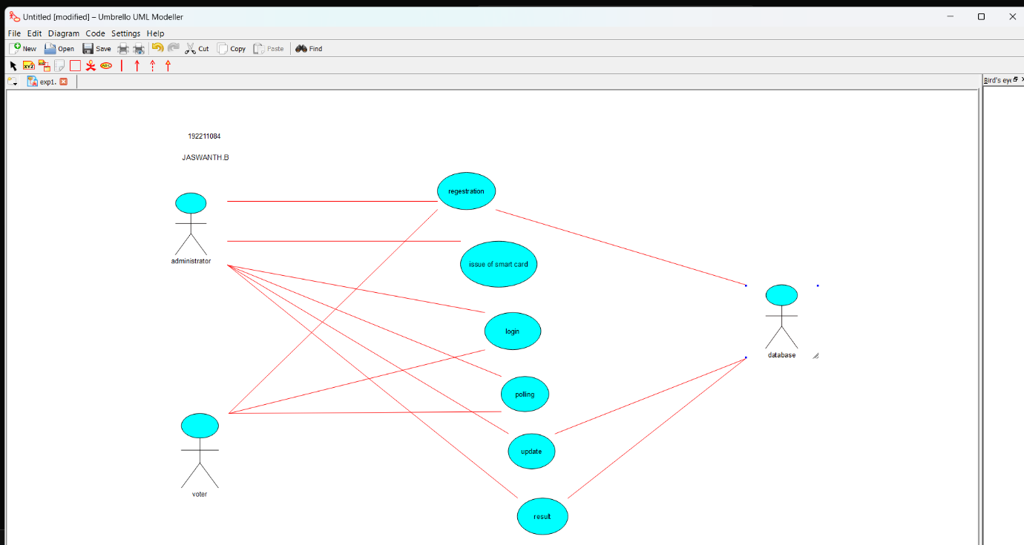

**Result:** Drawing a use case diagram for online voting system was completed successfully.

**2Q. Draw a USE-CASE diagram for Library Management System using CASE tools.**

**Aim:** To draw a use case diagram for library management system using case tools.

**Software Used:** Umbrello.

**Diagram:**

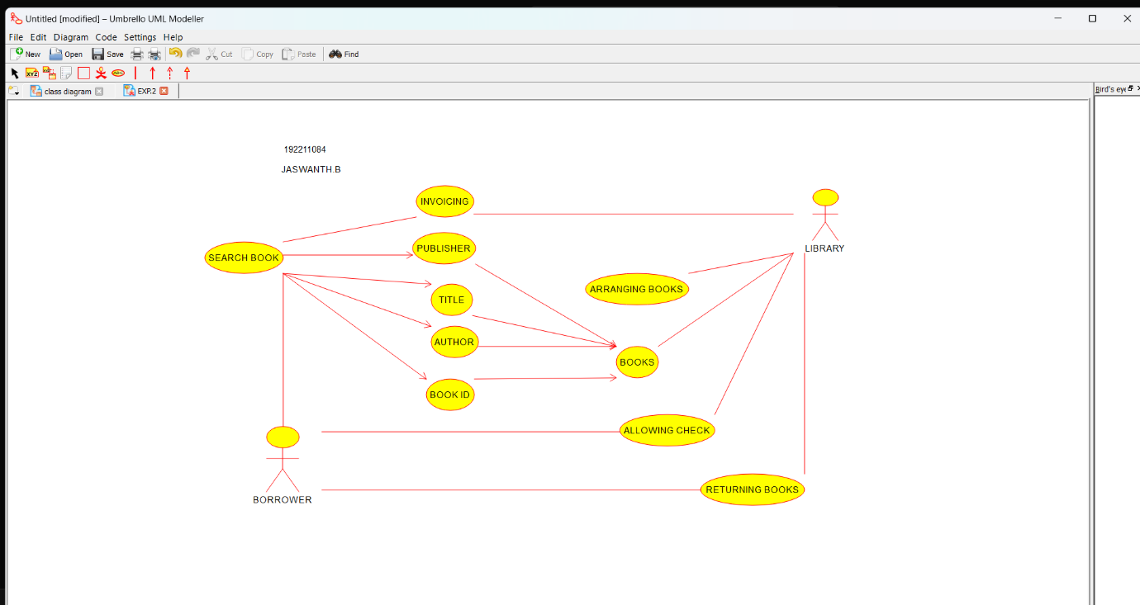

**Result:** Drawing a use case diagram for library management system was completed successfully.

**3Q. Draw and validate the flowchart to compute the quotient and remainder.**

**Aim:** To draw and validate the flowchart to compute the quotient and remainder.

**Software Used:** Raptor.

**Diagram:**

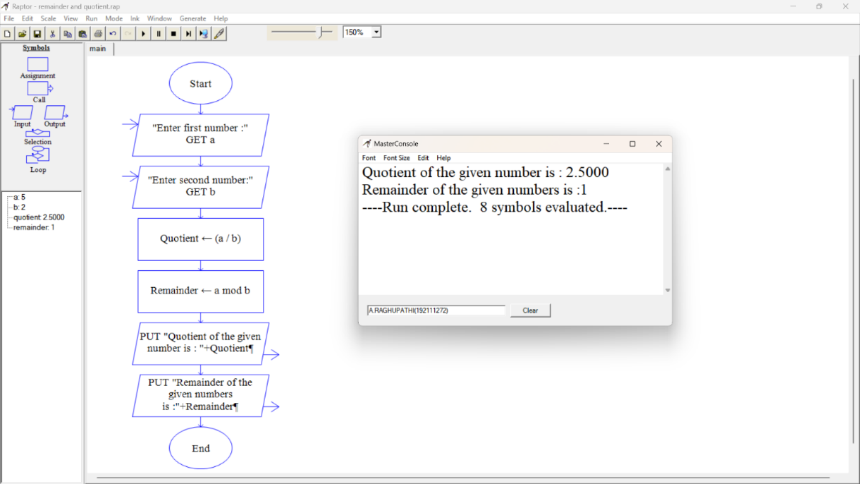

**Result:** Flowchart to compute the quotient and remainder was completed and output verified.

**4Q. Draw a USE-CASE diagram for Online Shopping system using CASE tools.**

**Aim:** To draw a use case diagram for online shopping system.

**Software Used:** Umbrello.

**Diagram:**

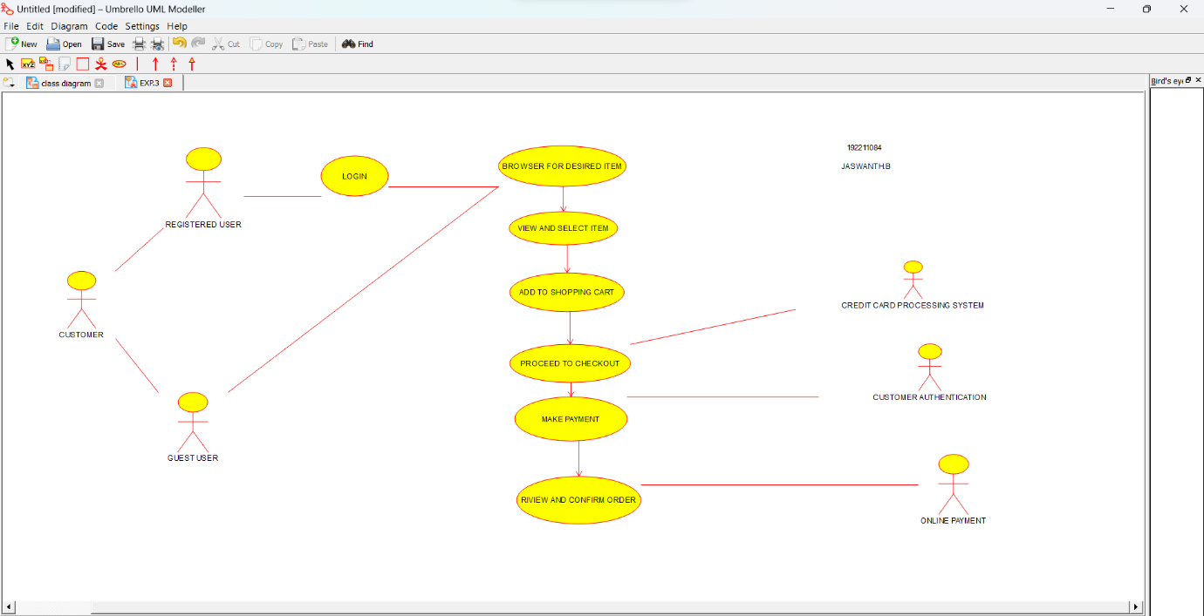

**Result :** Drawing of use case diagram for online shopping voting system was successfully completed.

**5Q. Draw a USE-CASE diagram for Online Railway Reservation System using CASE tools.**

**Aim:** To draw a use case diagram for online railway reservation system.

**Software Used:** Umbrello.

**Diagram:**

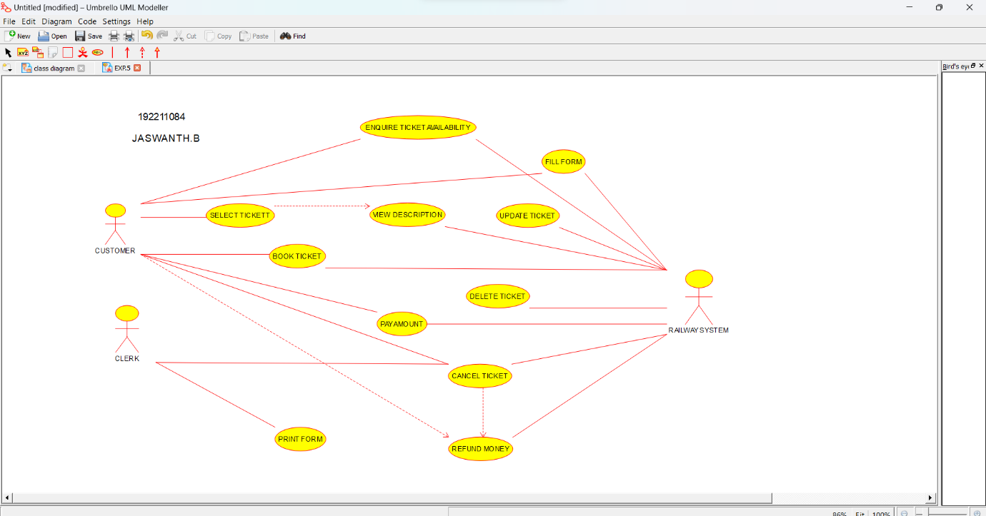

**Result :** Use case diagram for online railway reservation system was successfully completed.

**6Q. Draw a USE-CASE diagram for Hospital Management System using CASE tools.**

**Aim:** To draw a use case diagram for hospital management system.

**Software Used:** Umbrello.

**Diagram:**

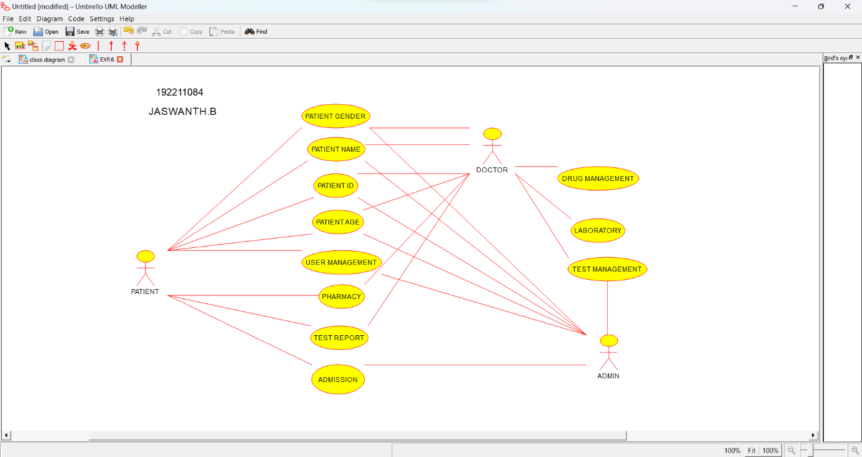

**Result :** Use case diagram for hospital management system was successfully completed.

**7Q. Draw a USE-CASE diagram for ATM System using CASE tools.**

**Aim:** To draw a use case diagram for ATM system.

**Software Used:** Umbrello.

**Diagram:**

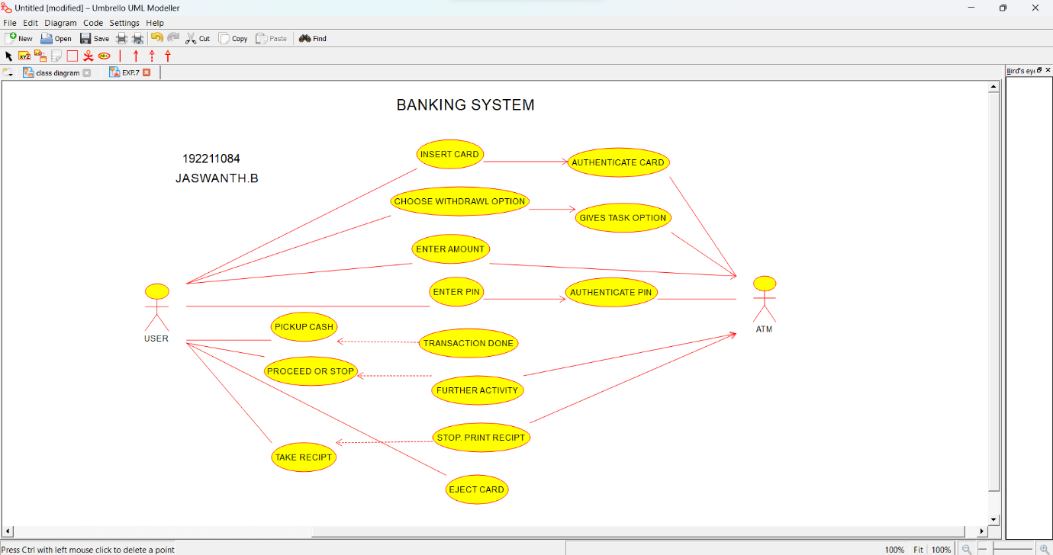

**Result :** Use case diagram for ATM system was completed successfully.

**8Q. Draw a USE-CASE diagram for Online college management System using CASE tools.**

**Aim:** To draw a use case diagram for online college management system.

**Software Used:** Umbrello.

**Diagram:**

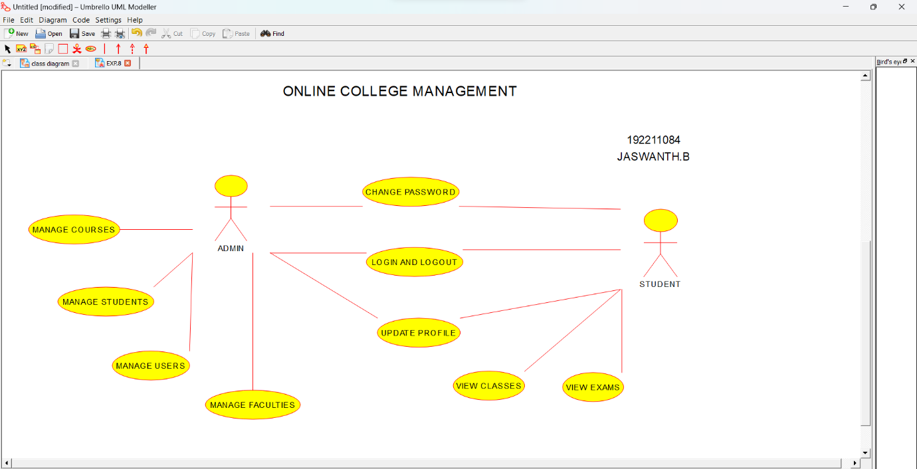

**Result:** Use case diagram for online college management system was successfully completed.

**9Q. Draw a USE-CASE diagram for Online Airline Reservation System using CASE tools.**

**Aim:** To draw a use case diagram for online airline reservation system.

**Software Used:** Umbrello

**Diagram:**

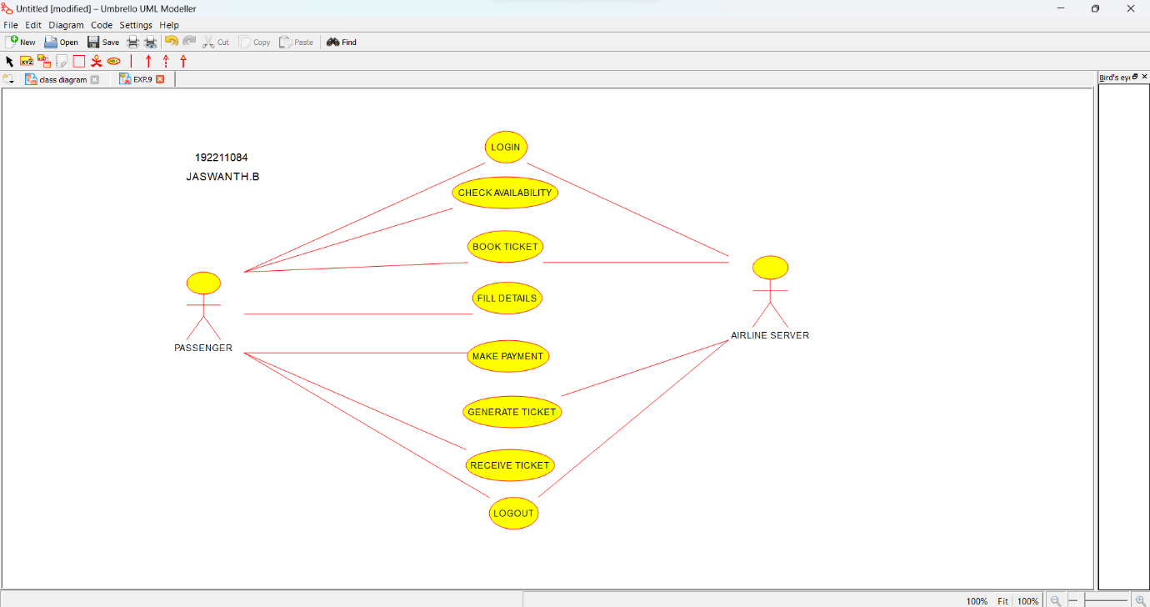

**Result:** Use case diagram for online airline reservation system was successfully completed.

**10Q. Draw a Class diagram for Online Airline Reservation System**

**using CASE tools.**

**Aim:** To draw a class diagram for online airline reservation system.

**Software Used:** Umbrello.

**Diagram:**

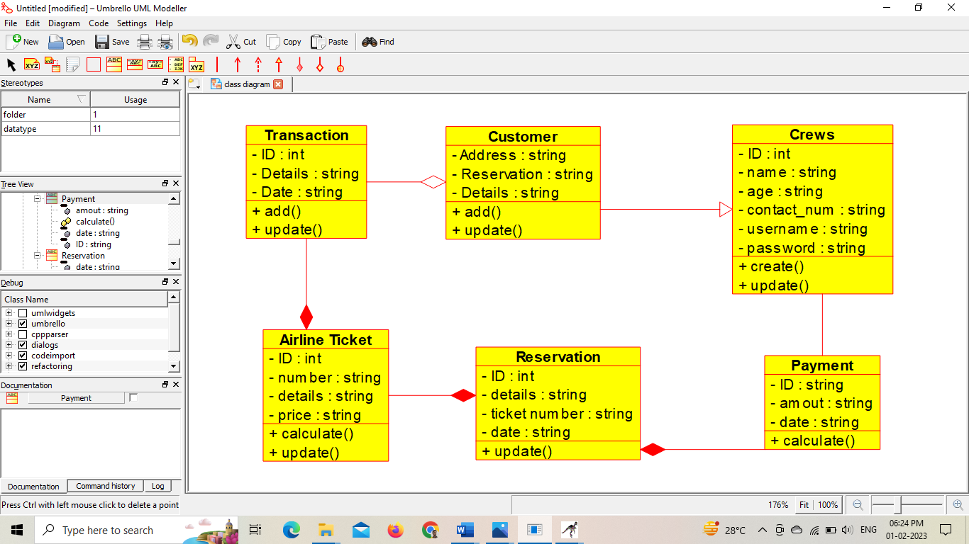

192211084

JASWANTH.B

**Result:** Class diagram for online airline reservation system was successfully completed.

**11Q. Draw a Class diagram for Online Voting System using CASE tools**

**Aim:** To draw a class diagram for online voting system.

**Software Used:** Umbrello.

**Diagram:**

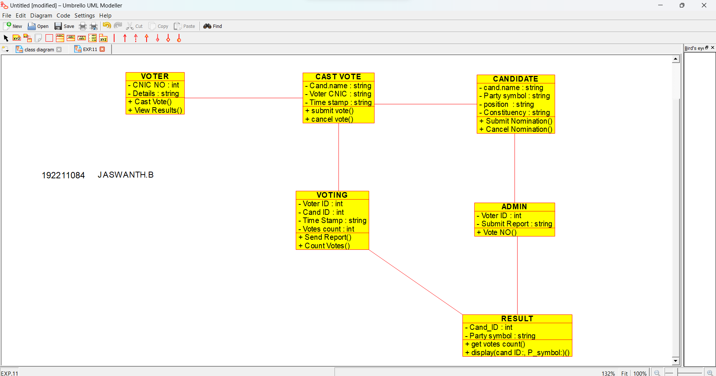

**Result:** Class diagram for online voting system was successfully completed.

**12Q. Draw a Class diagram for Library Management System using CASE tools.**

**Aim:** To draw a class diagram for library management system.

**Software Used:** Umbrello.

**Diagram:**

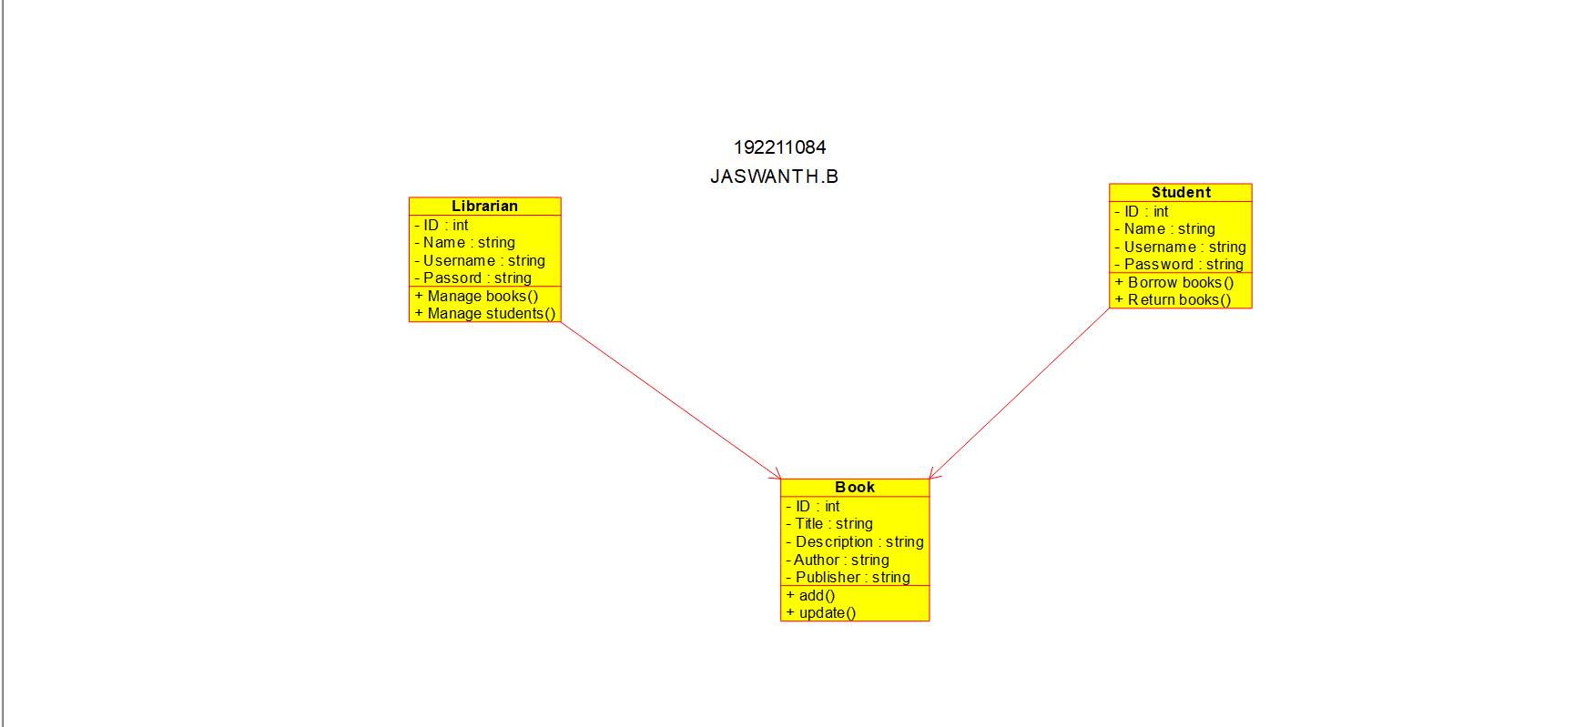

**Result:** Class diagram for library management system was successfully completed.

**13. Draw a Activity diagram for Online Voting System using CASE tools.**

**Aim:** To draw a activity diagram for online voting system.

**Software used:** Umbrello.

**Diagram:**

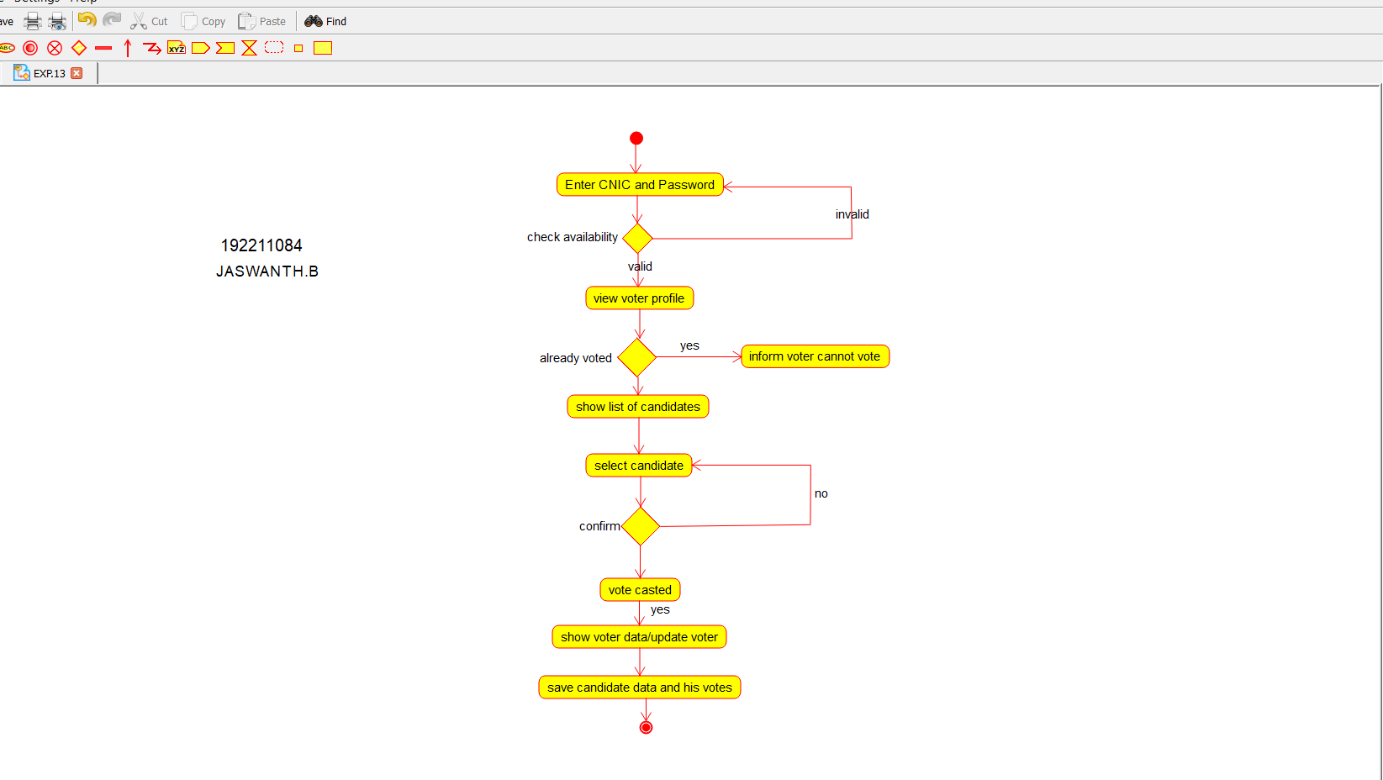

**Result:** Activity diagram for online voting system was successfully completed.

**14Q. Draw a Activity diagram for Library Management System using CASE tools.**

**Aim:** To draw a activity diagram for library management system

**Software used:** Umbrello.

**Diagram:**

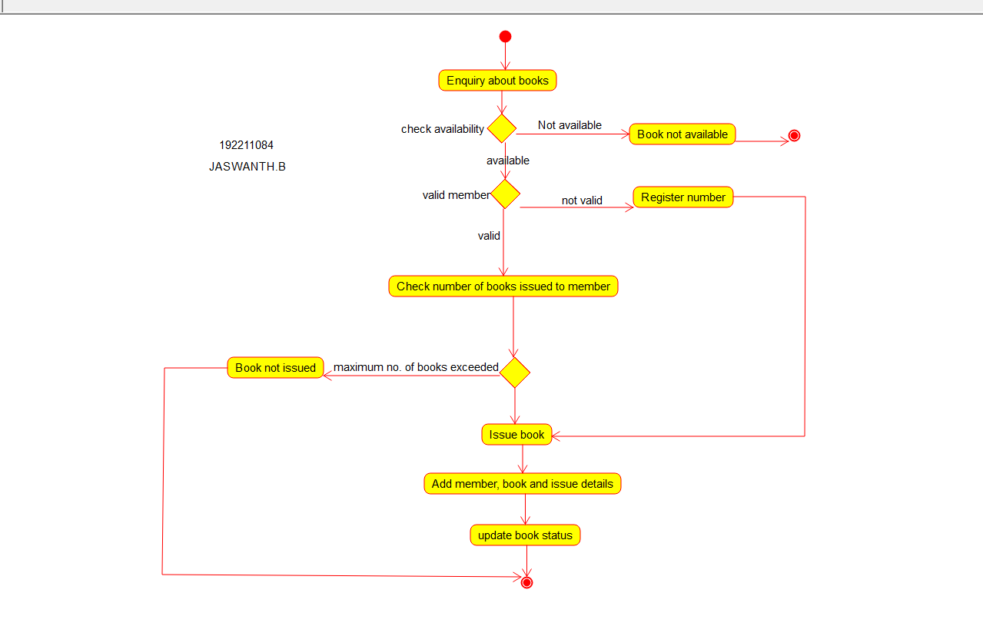

**Result:** Activity diagram for library management system was successfully completed.

**15Q. Draw a Activity diagram for Online Shopping system using CASE tools.**

**Aim:** To draw a activity diagram for online shopping system.

**Software used:** Umbrello.

**Diagram:**

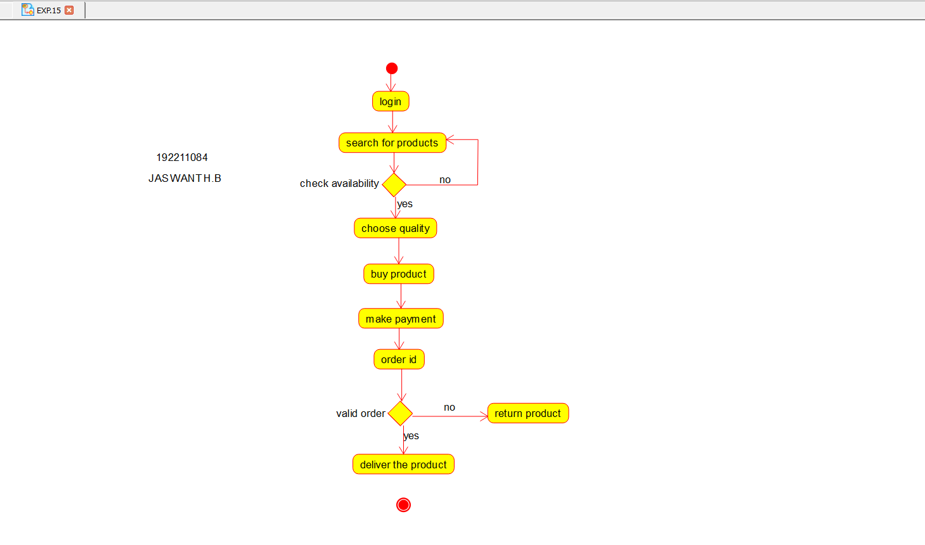

**Result:** Activity diagram for online shopping system was successfully completed.

**16Q. Draw a Activity diagram for Online Railway Reservation System using CASE tools.**

**Aim:** To draw a activity diagram for online railway reservation system.

**Software used:** Umbrello.

**Diagram:**

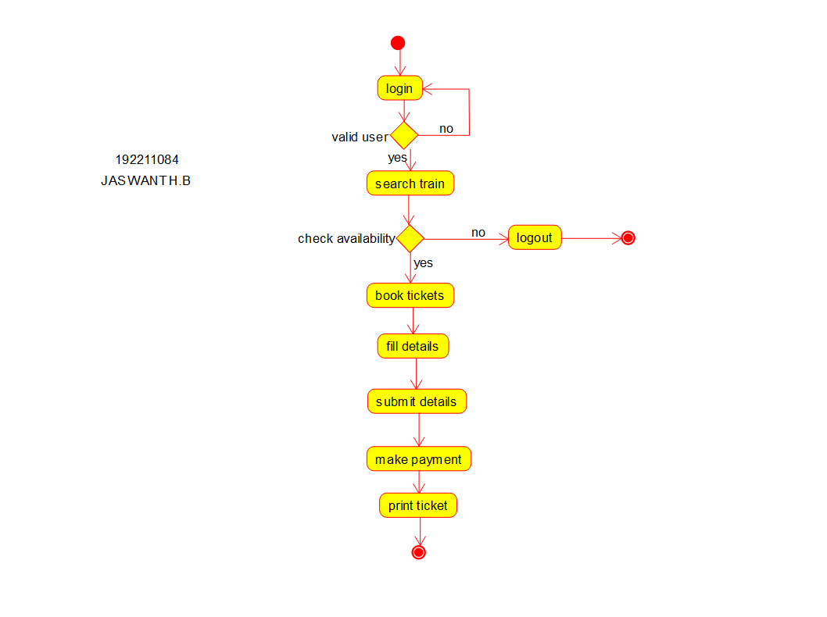

**Result:** Activity diagram for online railway reservation system was successfully completed.

**17Q. Draw a Activity diagram for Hospital Management System using CASE tools.**

**Aim:** To draw a activity diagram for hospital management system.

**Software used:** Umbrello.

**Diagram:**

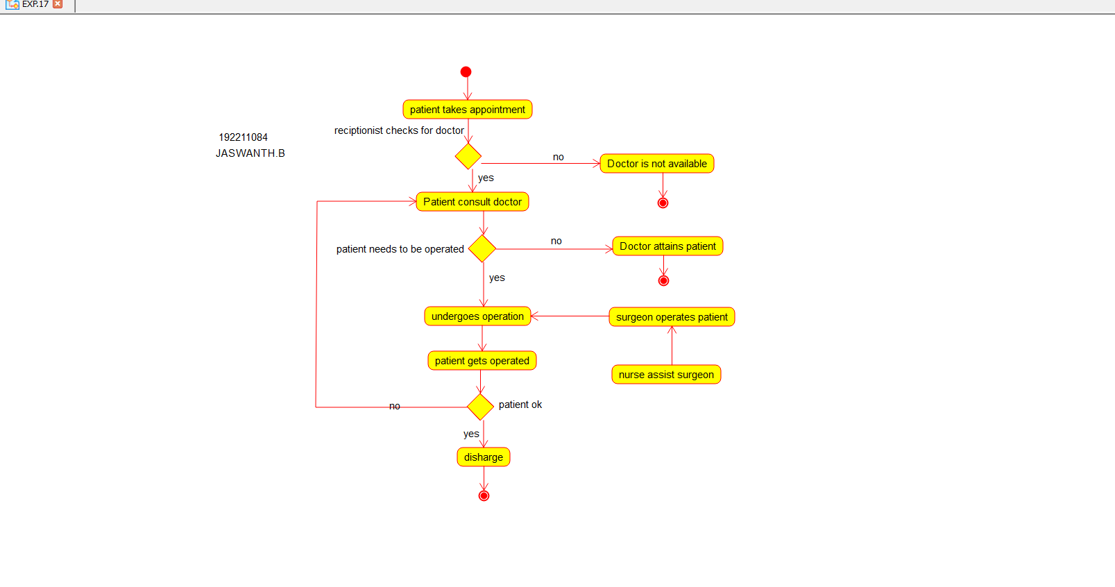

**Result:** Activity diagram for hospital management system was successfully completed.

**18Q. Using Raptor- Draw the flowchart to check whether the given number is a palindrome or not.**

**Aim:** To draw the flowchart to check whether the given number is a palindrome or not.

**Software used:** Raptor.

**Diagram:**

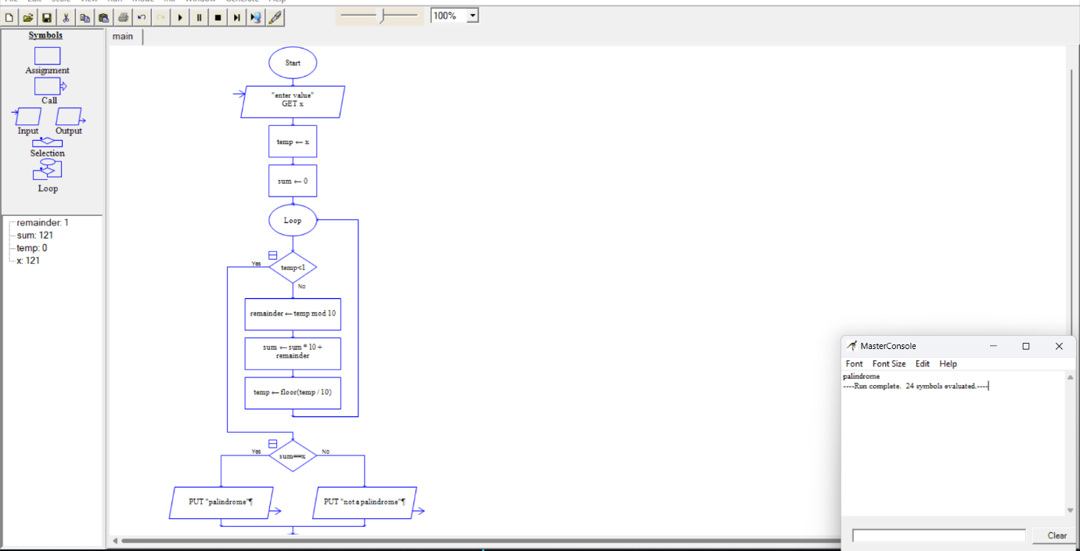

**Result:** Flowchart to check whether the given number is palindrome or not was completed and output verified.

**19Q.Using Raptor – Draw and validate the flowchart to swap two characters.**

**AIM:**

To draw and validate the flowchart to swap two characters.

**SOFTWARE USED:** Raptor

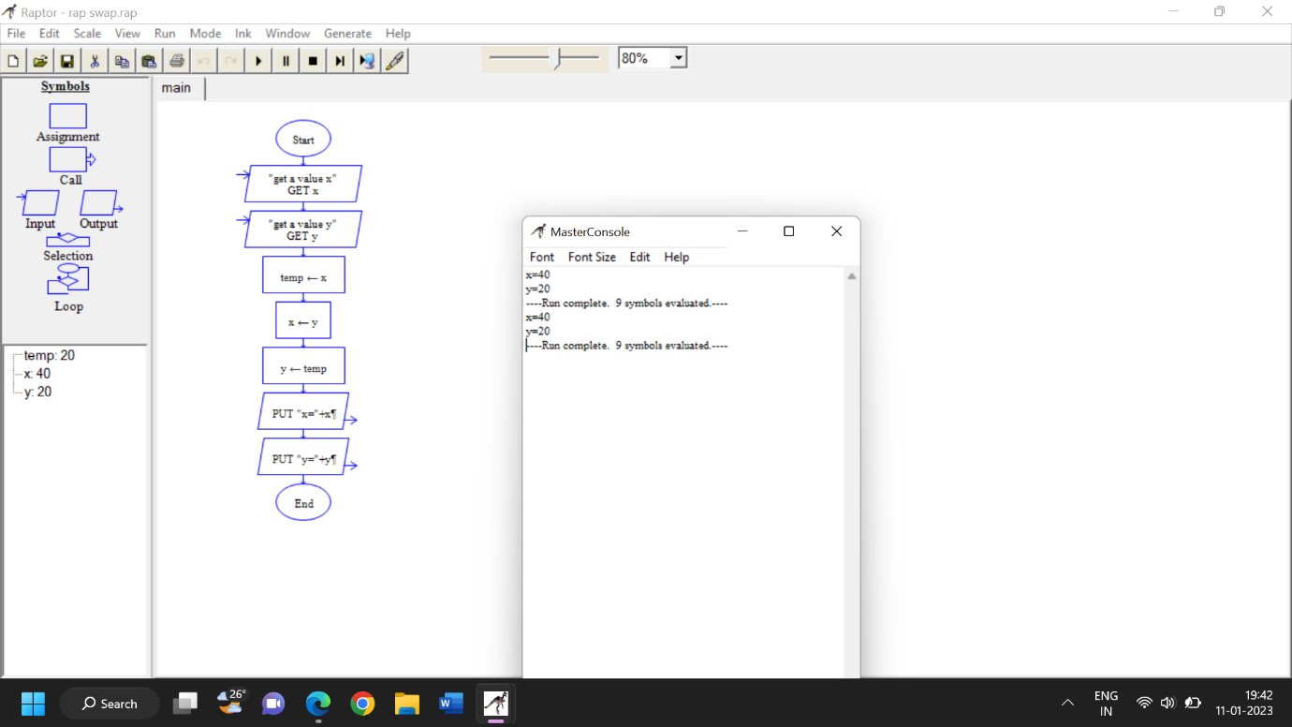

**RESULT:**

To draw and validate the flowchart to swap two characters was successfully completed.

**20Q.Using Raptor – Draw the flowchart to display the length of the string.**

**AIM:**

To draw and validate the flowchart to display the length of the string.

**SOFTWARE USED:** Raptor

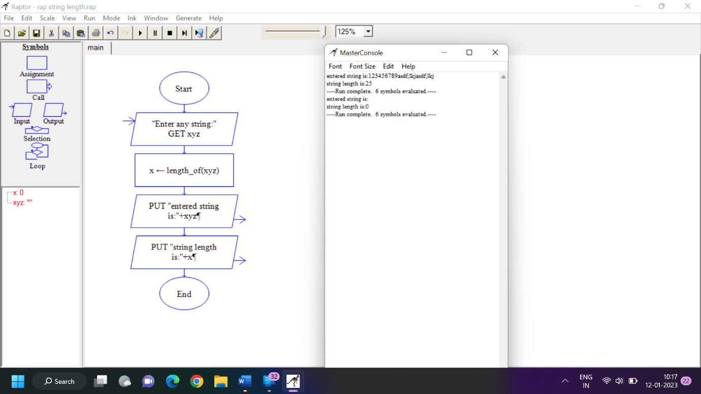

**RESULT:**

To draw and validate the flowchart to display the length of the string was successfully completed.